Please personalise and differentiate this book to meet the needs of the individual child before printing.

Nursery/School has been closed for a long time.

Insert School/nursery logo here

It has been closed because of Coronavirus.
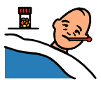

When Nursery/School was closed I stayed at home.
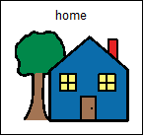
Nursery/School is ready to open again soon.

Insert School/nursery logo here

I will go back to nursery on:

My classroom will be __________
Insert photo of classroom here

I will put my coat and bag here

Insert picture of cloakroom/pegs here

I will play outside here
Insert photo of play area here

I will eat my lunch/snack here

Insert photo of snack table/lunch hall here

I will go to the toilet/have my nappy changed here

Insert photo of toilet/changing place here

My teacher will be (insert name of teacher)
Insert photo of teacher here

Other adults to help me will be (insert names of support staff)

Insert photo of support staff here
Insert photo of support staff here

I will be able to play with:
Insert images of favourite activities here

Insert images of favourite activities here

Going back to nursery will be OK!

